**ifstream example 2**

<https://www.youtube.com/watch?v=Iho2EdJgusQ> (same as previous)

#include "stdafx.h"

#include <iostream>

#include <fstream>

#include <string>

using namespace std;

int main()

{

ifstream inFile;

inFile.open("numbers.txt");

if (inFile.fail()) {

cerr << "Error opening file" << endl;

exit(1);

}

string item;

int count = 0;

int x, y;

inFile >> x >> y;

cout << "Num 1 is: " << x << endl;

cout << "Num 2 is: " << y << endl;

inFile.close();

return 0;

}

**numbers.txt** (wasn’t added in Resource folder, still worked):

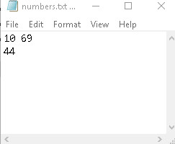

**Result:**

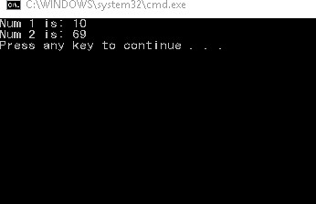

**Important notes:**

* inFile >> x >> y; through using this, we found that space does matter here
* When a text was inside the txt file, the program still read the string when looking for int values
* Keep in mind that 69 was num 2, not 44 on the next line